Chapter 5

RESULTS

Results
Output  (watt) | Ampere  (A) | Voltage  (V) | Wind Speed  after the nozzle  (At Middle of tunnel )  (m/s) | Wind Speed  after the nozzle  (m/s) | Wind Speed  outside the nozzle  (m/s)
2.338695 | 0.103942 | 22.5 | 5.8 | 5.5 | 2.6
0 | 0 | 0 | 2.3 | 2.2 | 1.6
0.956257 | 0.103941 | 9.2 | 4.2 | 4.2 | 2.1
3.783525 | 0.103943 | 36.4 | 9.7 | 9.2 | 4.4
1.954072 | 0.10394 | 18.8 | 5.5 | 5.2 | 2.4
2.59855 | 0.103942 | 25 | 5.8 | 5.6 | 3.5
4.479986 | 0.103944 | 43.1 | 10 | 9.8 | 6.1
4.750332 | 0.103946 | 45.7 | 12 | 11.2 | 6.5
5.415691 | 0.103948 | 52.1 | 13.6 | 13.4 | 7.2

Power = 0.5 x Swept Area x Air Density x (Velocity)³
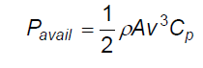

Where Power is given in Watts (i.e. joules/second), the Swept area in square meters, the Air density in kilograms per cubic meter, and the Velocity in meters per second.

5.2 Betz' Law :

The theoretical maximum power efficiency of any design of wind turbine is 0.59 (i.e. no more than 59% of the energy carried by the wind can be extracted by a wind turbine).
This is called the “power coefficient” and is defined
as: C_{p,max} = 0.59 – the real world limit is well below the Betz Limit with values of 0.35-0.45 common even in the best designed wind turbines. By the time you take into account other inefficiencies in a complete wind turbine system - e.g. the generator, bearings, power transmission and so on - only 10-30% of the power of the wind is ever actually converted into usable electricity
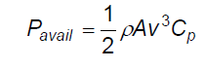
Where Power Coefficient, Cp = 0.4

The rotors swept area of PI x (0.48/2)² = 0.180955 m²

The air density is = 1.23 kg/m³

Results

P  ( watt) | Wind Speed after the nozzle  (At Middle of tunnel )  (m/s)
8.685432389 | 5.8
40.62774014 | 9.7
44.51511126 | 10
76.92211226 | 12
111.9758037 | 13.6

5.3 Measurement devices

5.3.1 Wind speed device

5.3.1.1The laser Doppler techniques:
An attempt is made to give a complete discussion of the principles of velocity measurement by the laser Doppler technique and an adequate description of the instruments and their application. The principles of laser optics are discussed and attention is given to the Doppler shift, the differential Doppler technique, signal processing techniques, directional discrimination and frequency shifting, and the properties of scattering properties. Such applications as studies of turbulence, the measurement of wind speed, and studies of combustion are discussed.
5.3.1.2 Anemometer:
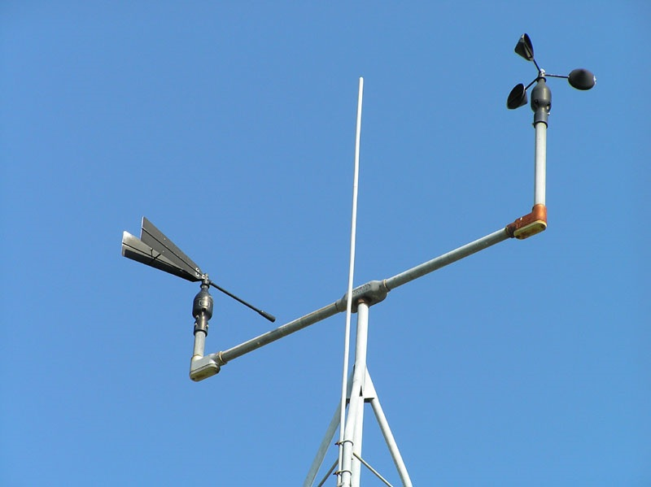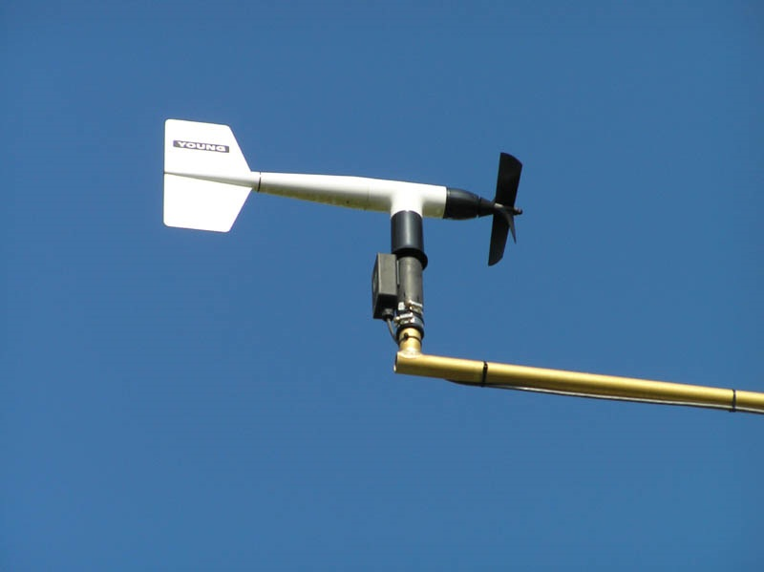An anemometer is a type of weather instrument that measures wind speed. Some of these instruments measure both wind speed and wind direction. Anemometers are common at weather stations. A cup anemometer is a type of instrument that uses three or four hemispherical cups mounted on horizontal arms on a vertical rod. The wind pushes the cups and causes the arms to rotate at a rate proportional to the wind speed. A windmill anemometer is a common instrument used at weather stations to obtain the wind speed. A wind vane is used as part of the anemometer to determine the wind's direction. As the wind flows over the windmill, the speed and direction of the wind can be measured with this instrument. Some scientific anemometers use the speed of sound to measure the wind speed more precisely in three dimensions. Wind direction is always given by where the wind is coming from, so that a west wind is blowing from the west and going towards the east.

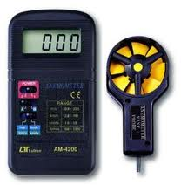

Digital Anemometer

5.3.2 RPM Measurement:

A sensor is necessary to sense shaft speed. Typical devices used for this purpose are shaft encoders (rotary pulse generators), proximity sensors, and photoelectric sensors.

Each of these devices sends speed data in the form of pulses.

Two factors affect the quality of this data:

• Number of pulses per revolution of the shaft (referred to as PPR). Higher PPR values result in better resolution.

• Symmetry of pulses. The symmetry of one pulse to the next can play a role in how consistent the RPM readings are. Symmetrical pulses give more accurate data.

Frequency measurement is better for fast-moving devices such as motors and turbines that typically turn in thousands of revolutions per minute.

Period measurement is better for devices that move more slowly, such as shafts that turn in less than 10 RPM.

5.3.3 Volt measurement device:

5.3.3.1 Voltmeter:

A voltmeter is an instrument used for measuring electrical potential difference between two points in an electric circuit. Analog voltmeters move a pointer across a scale in proportion to the voltage of the circuit; digital voltmeters give a numerical display of voltage by use of an analog to digital converter.

Digital voltmeter:

Digital voltmeters (DVMs) are usually designed around a special type of analog-to-digital converter called an integrating converter.

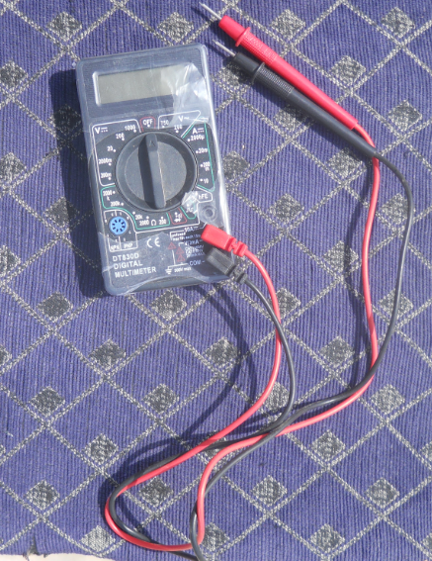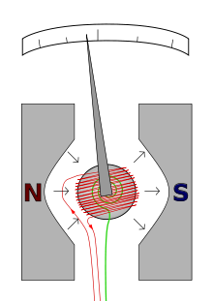Digital voltmeters necessarily have input amplifiers, and, like vacuum tube voltmeters, generally have a constant input resistance of 10 megohms regardless of set measurement range.

5.3.4 Torque measurement device

TTC - Torque Sensors:
TTC sensors are designed to be mounted onto existing drive shafts and spindles. The measurement principle is based on strain gauges. The signal is transmitted from the rotor using telemetry systems. The measurement amplifier is supplied with energy by induction. Thus the TTC-sensors operate contact-free. The TTC-protection and support ring is patented. The manufacturing and application of these sensors for the most extreme industrial environments, such as rolling mills, cement factories or mining facilities, is ACIDA’s specialty

Besides torque, other parameters such as axial force and bending moment in drive shafts as well as pressure, temperature or vibrations can be measured in rotating components using the TTC technology.

